Big 5 Stock Trends Analysis

(Project One)

Keyur Patil

Sydney Robertson

Katrina Smith

Scooter Smith

James Williams

The goal of project one was to test our understanding of data: importing, cleaning and analyzing. Our group analyzed the stock data of the Big 5 (Amazon, Apple, Google, Microsoft, and Facebook) to look for trends, and attempt to predict how these stocks would perform in the future based on their history.

Firstly, the data was read and cleaned to determine which stock was the best and worst investment, and was the most stable over the last 10 years.

We started with a calculator for a daily percent change in stock value over the full ten years. Our initial visualizations are line graph subplots using Matplotlib with each stock compared to the NASDAQ index (Fig.1). This helped us get an initial starting point for how the visualizations would turn out, but with the span of time in the data set we decided to pivot to

Plotly visualizations. This allowed us to have better detail shown in the graphs, and gave us the ability to manipulate the time range (Fig.2).

From this data, yearly events were looked into to see how they would contribute to stock volatility. The typical cause-and-effect event where a factor causes a spike or a drop in values. For example, seeing if an Apple KeyNote or a Microsoft product launch creates a spike. In the “Percent Over Time” graphs (Figures 1 through 7), we can see the stock volatility and see how these are compared to the overall Index(Nasdaq).

From these findings a second question occurred was incurred to see if there were better times to buy and sell throughout the year. Expecting to find a set answer in the findings, it can be concluded that the best time to buy a particular stock would be now as the overall general stock market trend is ever rising

The fourth question we had was if the Big 5 outperformed or underperformed the NASDAQ composite over the 10 year time frame. When comparing average percent change over time, each of the Big 5 stocks outperformed the NASDAQ over the 10 year period (See Figure 7). Amazon had the highest average percent change by a clear margin. However, when comparing the percent change of the Big 5 over 10 years to the index in a line graph, the NASDAQ and the Big 5 behaved very similarly (See Figures 1-6). With a few exceptions for events like Facebook’s launch which had major ups and downs (See Figure 5), the Big 5 fluctuations closely mirror the market as a whole. Overall, while the Big 5 do have consistently higher percent changes, it is tough to explicitly say that the Big 5 outperform the index because they follow the same trends as the overall market.

To determine which stock had the most shares bought over the last 10 years, we had to switch our focus from open/close daily values and percent changes to daily purchase volume. We first grouped the data by stock name then summed together each day’s purchase volume for each of the Big 5 companies. Interestingly, Microsoft, our “worst performer” from Question 1, actually has the largest number of shares purchased out of the Big 5, owning 42% of the total purchase volume (See Figure 8). It appears that Microsoft’s consistent return, although it is lower than the other companies, is more attractive to investors because it offers increased reliability over a more volatile option such as Apple.

Lastly, could we predict what the stock prices were going to be on August 31, 2020, and how did our prediction correlate with the actual price. We used the Plotly Linear Regression function to determine this. The only major issue was we had to convert the time range in serial time to be used as an integer in the function. Every stock shows a continued increase for the next year, with Amazon showing the steepest increase predicted.

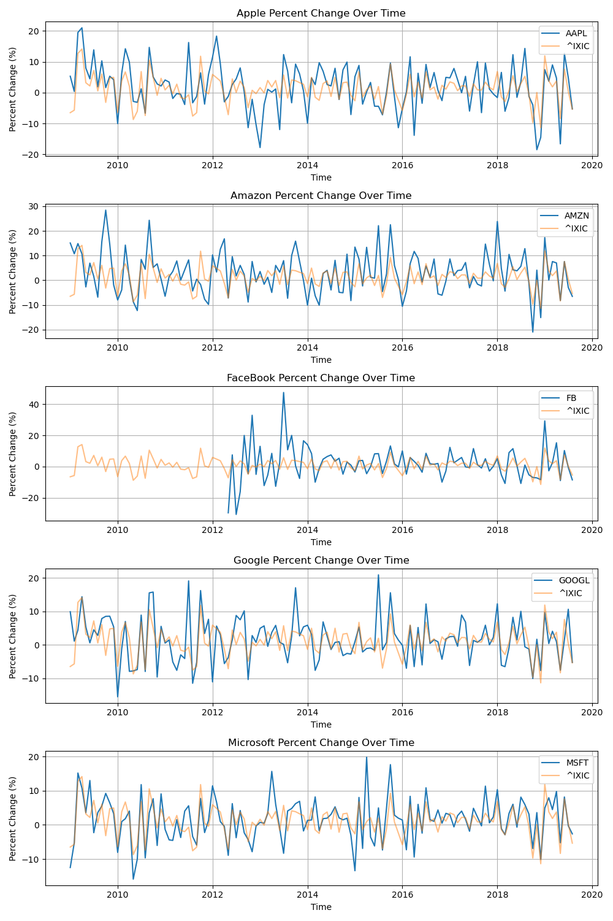

Figure 1. Percent Change Over Time

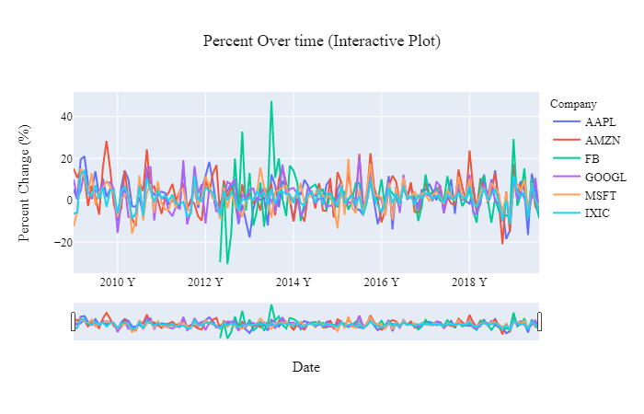Figure 2. Percent Over Time - Line Graph

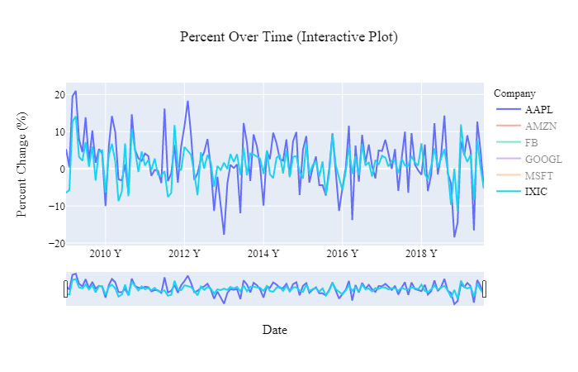

Figure 3. Percent Over time (Apple + index) - Line Graph

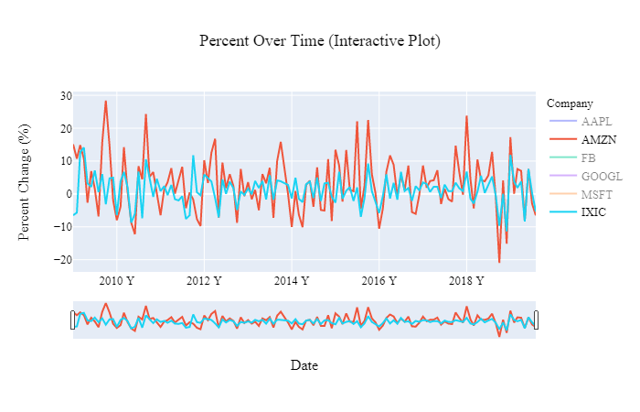

Figure 4. Percent Over time (Amazon + index) - Line Graph

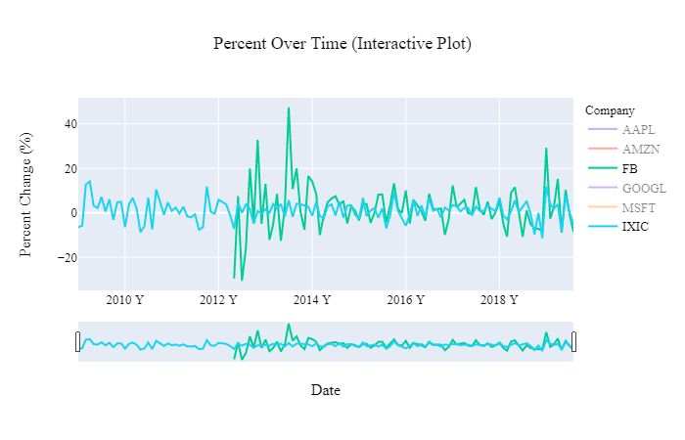

Figure 5. Percent Over time (Facebook + index) - Line Graph

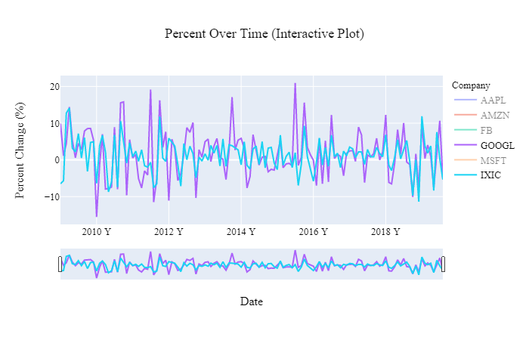

Figure 6. Percent Over time (Google + index) - Line Graph

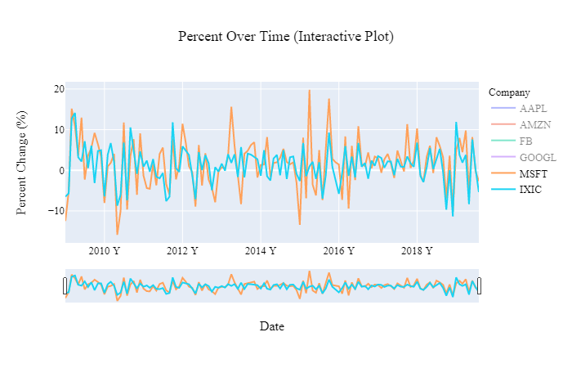

Figure 7. Percent Over time (Google + index) - Line Graph

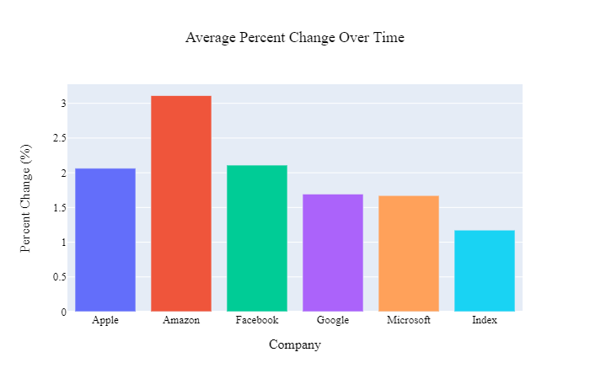

Figure 8. Average Percent Change Over time - Bar Graph

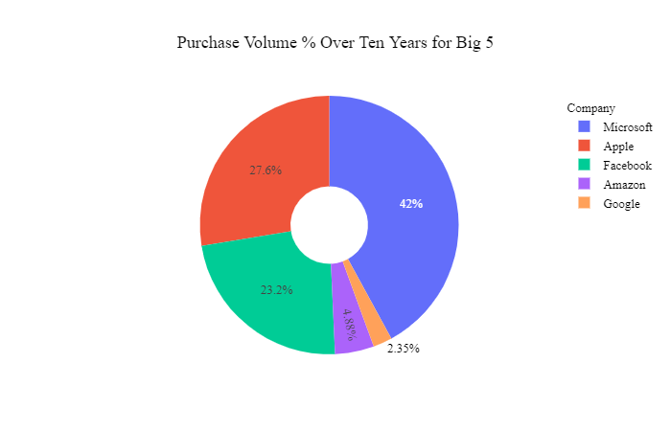

Figure 9. Purchase Volume % Over Ten Years for Big 5 - Pie Graph

Figure 10. Open vs. Close Daily Difference - Candlestick (box-and-whisker) Graph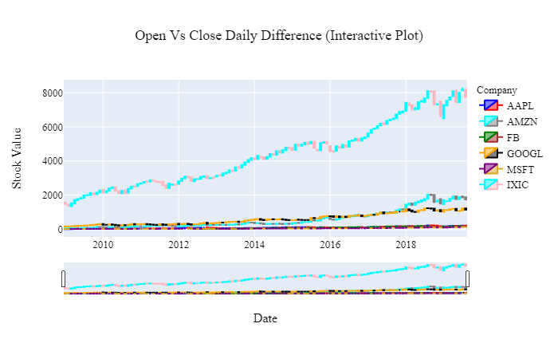

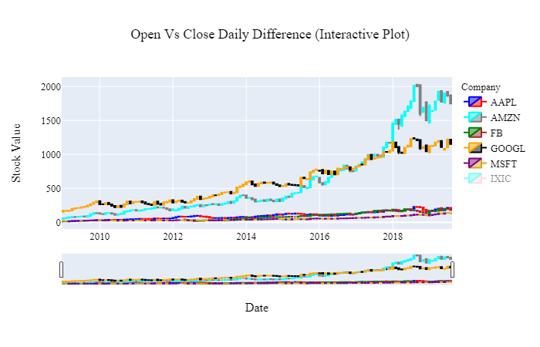

Figure 11. Open vs. Close Daily Difference (without Index) - Candlestick (box-and-whisker) Graph

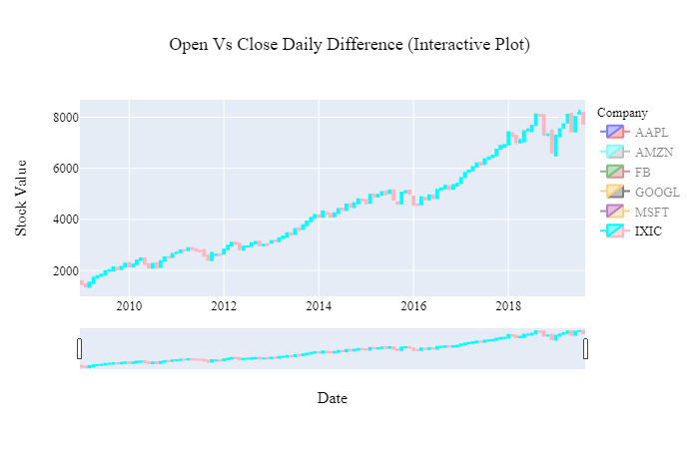

Figure 12. Open vs. Close Daily Difference (Index) - Candlestick (box-and-whisker) Graph

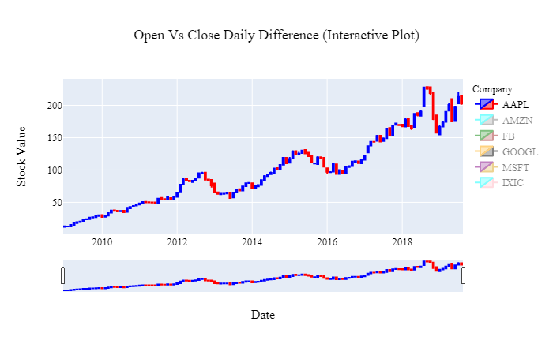

Figure 13. Open vs. Close Daily Difference (Apple) - Candlestick (box-and-whisker) Graph

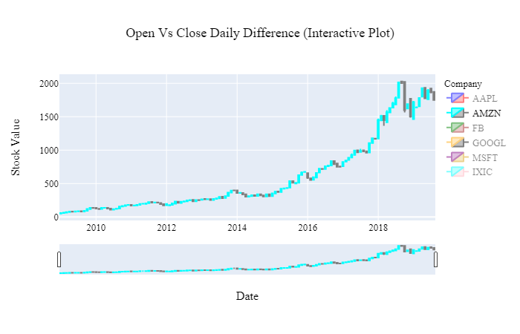

Figure 14. Open vs. Close Daily Difference (Amazon) - Candlestick (box-and-whisker) Graph

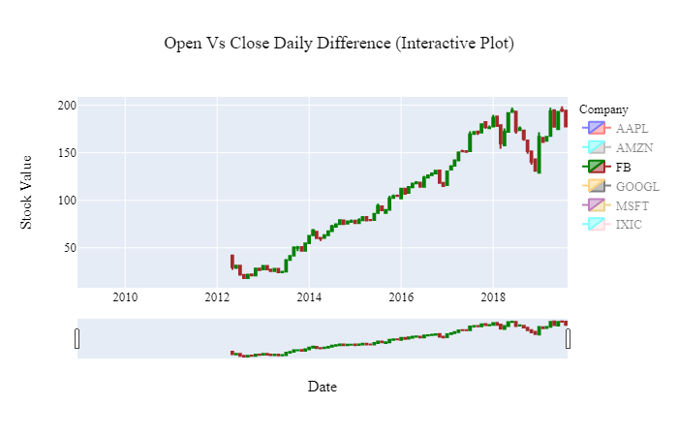

Figure 15. Open vs. Close Daily Difference (Facebook) - Candlestick (box-and-whisker) Graph

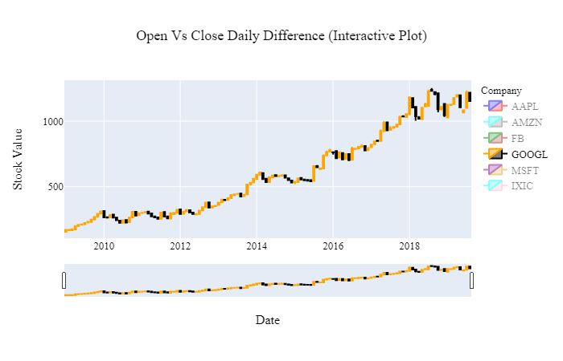

Figure 16. Open vs. Close Daily Difference (Google) - Candlestick (box-and-whisker) Graph

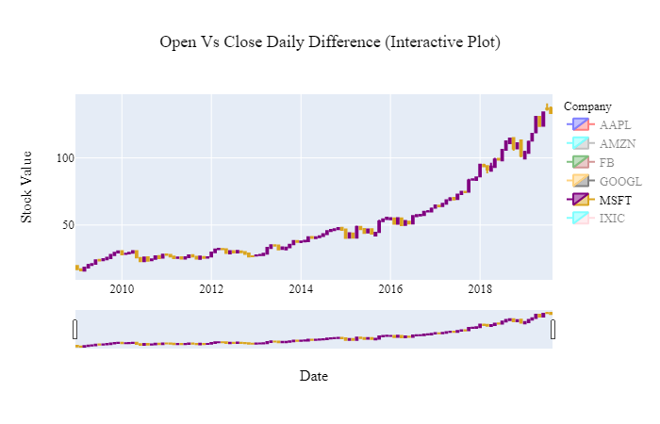Figure 17. Open vs. Close Daily Difference (Microsoft) - Candlestick (box-and-whisker) Graph

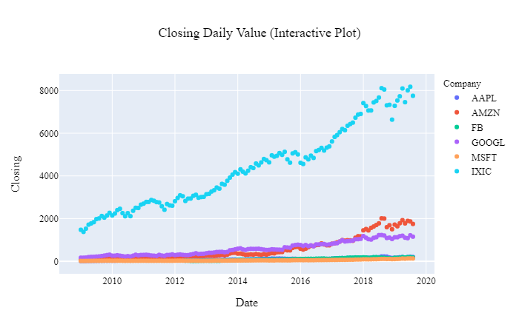

Figure 18. Closing Daily Value - Scatter Plot

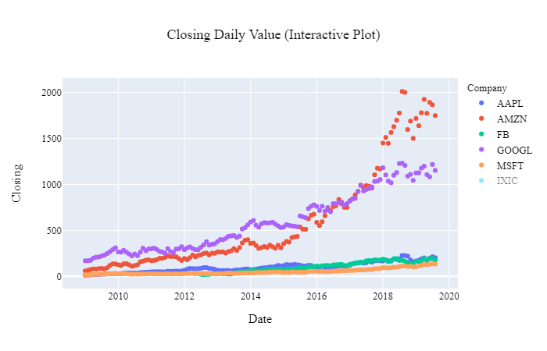

Figure 19. Closing Daily Value (without Index) - Scatter Plot

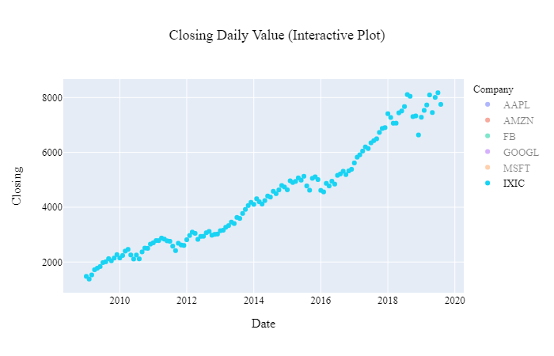

Figure 20. Closing Daily Value (Index) - Scatter Plot

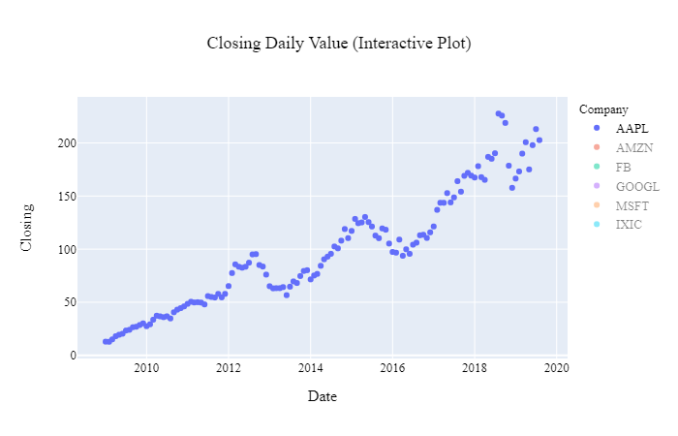

Figure 21. Closing Daily Value (Apple) - Scatter Plot

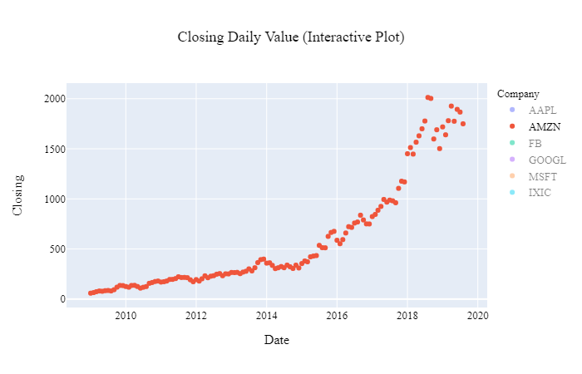

Figure 22. Closing Daily Value (amazon) - Scatter Plot

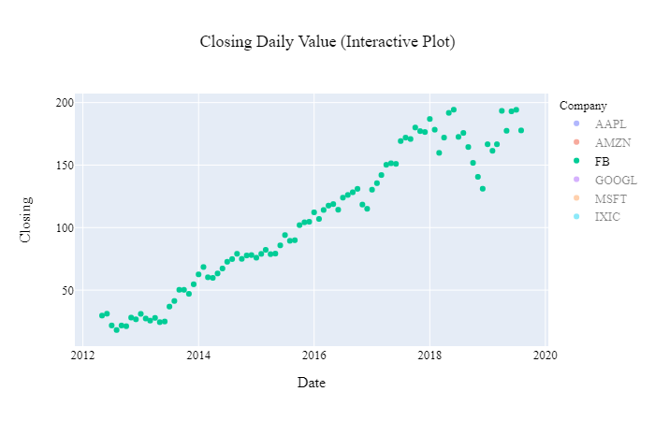

Figure 23. Closing Daily Value (Facebook) - Scatter Plot

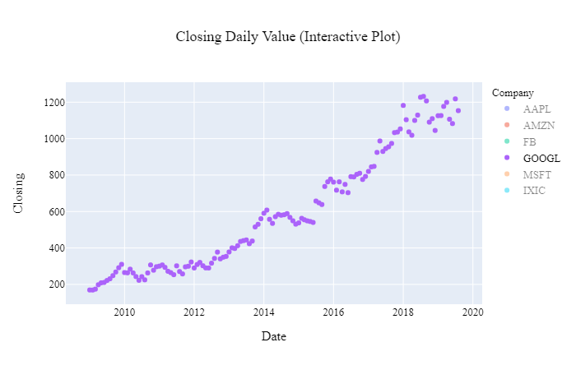

Figure 24. Closing Daily Value (Google) - Scatter Plot

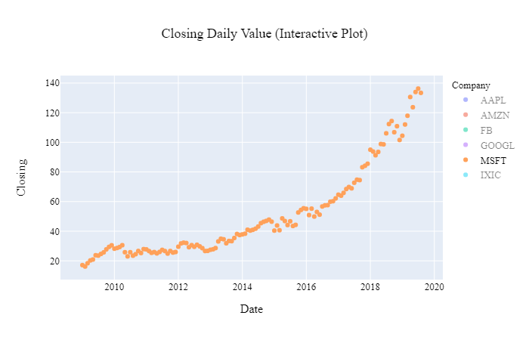

Figure 25. Closing Daily Value (Microsoft) - Scatter Plot

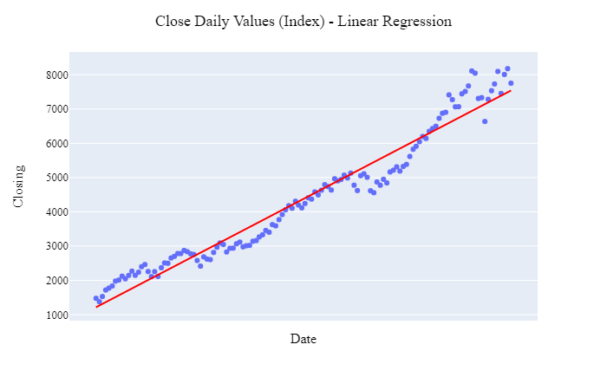

Figure 26. Close Daily Value (Index) - Linear Regression

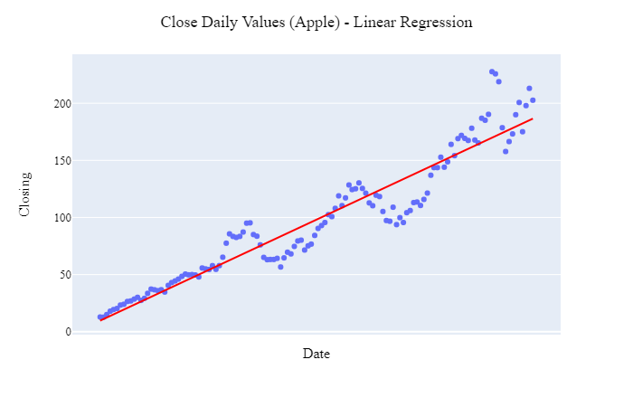

Figure 27. Close Daily Value (Apple) - Linear Regression

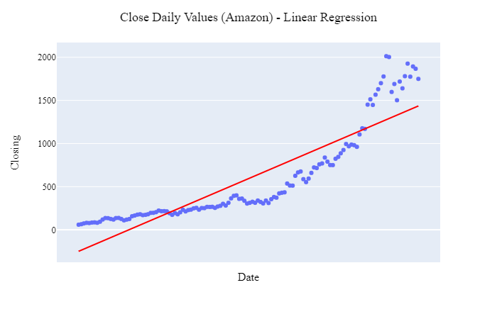

Figure 28. Close Daily Value (Amazon) - Linear Regression

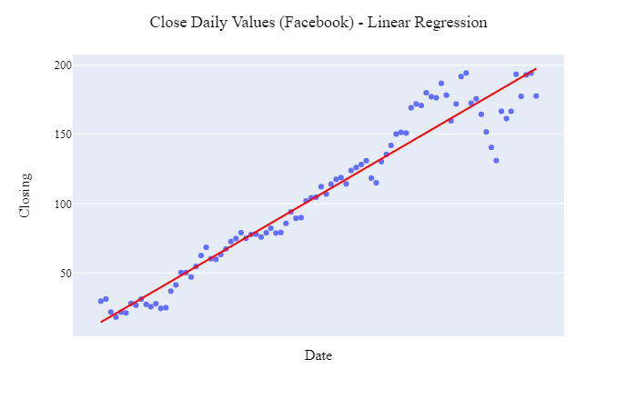

Figure 29. Close Daily Value (Facebook) - Linear Regression

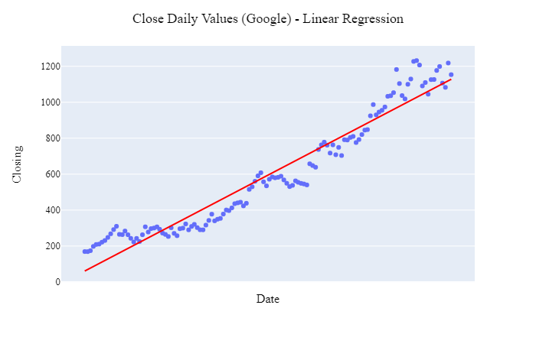

Figure 30. Close Daily Value (Google) - Linear Regression

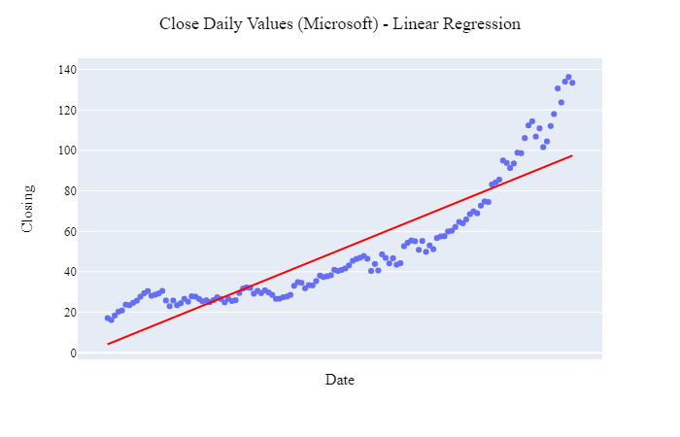

Figure 31. Close Daily Value (Microsoft) - Linear Regression